Suresh Shrestha
3/24/2026
Module 1.2 Assignment

1. Screenshot of GitHub repository
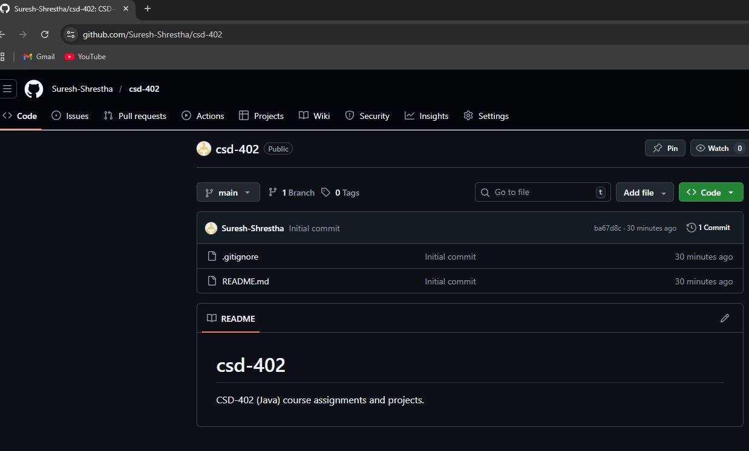

2. Screenshot of local directory
